
Óbuda University
Donát Bánki Faculty of Mechanical and Safty Engineering
Institute of Materials and Manufacturing Sciences

TITLE OF THE THESIS WORK

OE-BGK Name of Student: Name
2020. ID Number of the Student: 000123/FI12904/KVI
Óbuda University
Donát Bánki Faculty of Mechanical and Safty Engineering
Institute of Materials and Manufacturing Sciences

HALLGATÓI NYILATKOZAT

Alulírott hallgató kijelentem, hogy a szakdolgozat saját munkám eredménye, a felhasznált szakirodalmat és eszközöket azonosíthatóan közöltem. Az elkészült szakdolgozatban található eredményeket az egyetem és a feladatot kiíró intézmény saját céljára térítés nélkül felhasználhatja, a titkosításra vonatkozó esetleges megkötések mellett.

Budapest, 2020.

..................................................
Signature of Student

Contents

1. Introduction 1
2. Theoretical background 2
2.1 Citations 2
2.1.1 Place of the citations 2
3. Project 3
3.1 Figures, tables 3
3.2 Formula 4
4. Summary 5
5. Reference list 6
6. Annexes 7

Please use the decimal system of headings with no more than three levels.

No of pages of the whole thesis work should be 40-60 plus the Annex.
This template is comply with the rules of the University.

Introduction

This is the first chapter of the thesis work. You should provide it 1-1,5 pages. The introduction should not contain any undefined abbreviations or unspecified references. It contains the importance of the degree project, the aims and goals. You can introduce also the company if it necessary.

Use a normal, plain font (12-point Times Roman) for text. Line spacing: 1,5.
A4, margins: upper 4 cm, left 3,5 cm and right 2,5 cm, down 2,5 cm.
Use the automatic page numbering function to number the pages. Do not use field functions. Use tab stops or other commands for indents, not the space bar.

Theoretical background

This chapter (and subchapters) should be max 40% of the whole thesis work (10-15 pages).
You have to define the title of the chapters and subchapters.
Use the relevant publications. The publications can be: book, journal article, websites, online information, catalogue etc.
Abbreviations should be defined at first mention and used consistently thereafter.

Use a normal, plain font (12-point Times Roman) for text. Line spacing: 1,5.
A4, margins: upper 4 cm, left 3,5 cm and right 2,5 cm, down 2,5 cm.

Citations

Cite references in the text by number in square brackets. Some examples:
Negotiation research spans many disciplines. [1]
This effect has been widely studied by [2] and this ……
Don’t use citations in the title of the chapters, subchapters!

Place of the citations

The list of references should only include works that are cited in the text and that have been published or accepted for publication. Do not use footnotes or endnotes as a substitute for a reference list.
In the text the first citation will be [1] and you should give the full information of the publication in the chapter (reference list).

Project

In this part (some chapters) you can determine the problem and the process of the problem-solving. You should provide it 20-25 pages.

Use a normal, plain font (12-point Times Roman) for text. Line spacing: 1,5.
A4, margins: upper 4 cm, left 3,5 cm and right 2,5 cm, down 2,5 cm.

Figures, tables

Figure Numbering
All figures are to be numbered using Arabic numerals. Figures should always be cited in text in consecutive numerical order. Figure parts should be denoted by lowercase letters (a, b, c, etc.).
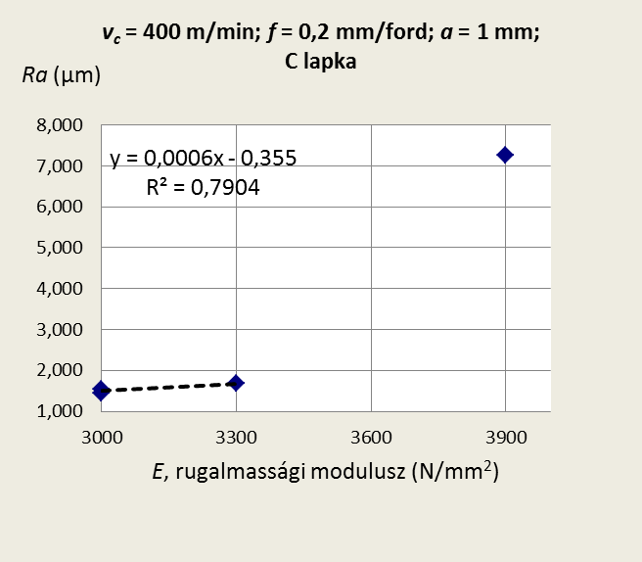
Figure 1. Example of the figure [6]
Figure Captions
Each figure should have a concise caption describing accurately what the figure depicts. Include the No. of the Figure in the text. Figure captions begin with the term Figure followed by the figure number. No punctuation is to be included after the number, nor is any punctuation to be placed at the end of the caption. Identify previously published material by giving the original source in the form of a reference citation at the end of the figure caption.

Tables
All tables are to be numbered using Arabic numerals. Tables should always be cited in text in consecutive numerical order. For each table, please provide a table caption (title) explaining the components of the table. Identify any previously published material by giving the original source in the form of a reference at the end of the table caption.

Table 1.: Example of the table [7]
Readable text |  |  | Readable text

If the table is to big put it in the Annex.

Formula

Example of the formula:

Formula of the capability [8]:
$C_{x}=\frac{\text{FTH}−\text{ATH}}{6⋅\hat{σ}}=\frac{\text{TM}}{6⋅\hat{σ}}$ (3.1)
where: C_{x}: capability;
FTH: Upper tolerance limit;
ATH: Lower tolerance limit;
TM: Tolerance;
$\hat{σ}$: standard variation.

Summary

This is the last chapter of the thesis work. You should provide it 1-1,5 pages. It contains the results of the degree project. You can introduce also the practical application.

Reference list

Some examples of the different publications.

Book:
[1] South, J., Blass, B.: The future of modern genomics. Blackwell, London, 2001.

Book chapter:
[2] Brown, B., Aaron, M. (2001). The politics of nature. In: Smith J (ed) The rise of modern genomics, 3rd edn. Wiley, New York, 2001. pp 230-257

Journal article:
[3] Baigorria, G. A., Jones, J. W., & O'brien, J. J. O.: Understanding spatial rainfall variability in southeast USA at different timescales. International Journal of Climatology, 27, 2007. p. 749–760.

Online article, documentation, information etc.
[4] Dr. Szabó László: Forgácsolás, hegesztés. Miskolc 2000.
http://mek.oszk.hu/01200/01200/html/html

Annexes

All annexes are to be numbered using Arabic numerals. For each annex, please provide a title. Annexes should always be cited in text in consecutive numerical order.

Examples:

Annex 1.: Components of the machine.
Annex 2.: Flowchart of the manufacture.

